Reserving a Book from the Library Catalog
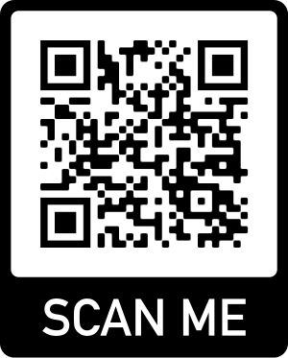
NOTE: To view this QR Code, you must have a QR Code Reader app or some other way to view QR codes on your device

- Go to the library catalog’s website: https://ush.scoolaid.net/bin/home (or scan the QR code) and click ‘Login’ in the top right corner.
- On the login screen, type in your 4-digit lunch code as your username; no password needed.
- If you do not know what kind of book you want yet, start by clicking on the green ‘Search’ tab or use the search box at the top of the screen.
- If you already have a book or author in mind, look for a yellow/mustard colored ‘Circulation’ tab, hover over it, and click ‘Reserve.’
- A box appears asking you to Enter Name/Barcode; type your name. If more than one name appears after you click ‘OK,’ select the correct name so that you are on the correct account.
- On the right side of the screen will be a magnify glass icon and the words ‘Quick Title Search.’ Once you click on the quick title search, a white search box will appear. Type in your search: search terms (keyword), title or author.
- Once you find the book you want, you can reserve the book in one of two ways:
- Click on the title to find out more info about the book; under the picture of the book cover, click ‘Reserve.’
- On the far right of the list of titles, under ‘Action,’ click ‘Reserve.’
- The requested title should show up on the screen as ‘Item(s) to Reserve’ but you must also click ‘Reserve’ to complete the request.
- Make sure you see a message that states ‘This title is on Hold and will expire on (specific date).’
- If you reserved a title by mistake, click the box to the far right of the title and click ‘Cancel Selected Items’ to delete the request.
- Mrs. Berry will do her best to deliver books to your pod on your next scheduled day of school, after you have made your request. Exceptions: her absence the previous day(s), book is too mature, book is in quarantine upon its return, or if a book is being repaired.
- Never remove a book from the library without permission even if you have reserved it with Mrs. Berry! The library is supervised by other teachers during the day; they are not designated (allowed), or know how to check out books. All books should be reserved online as described.
- Please be patient! Thank you!

